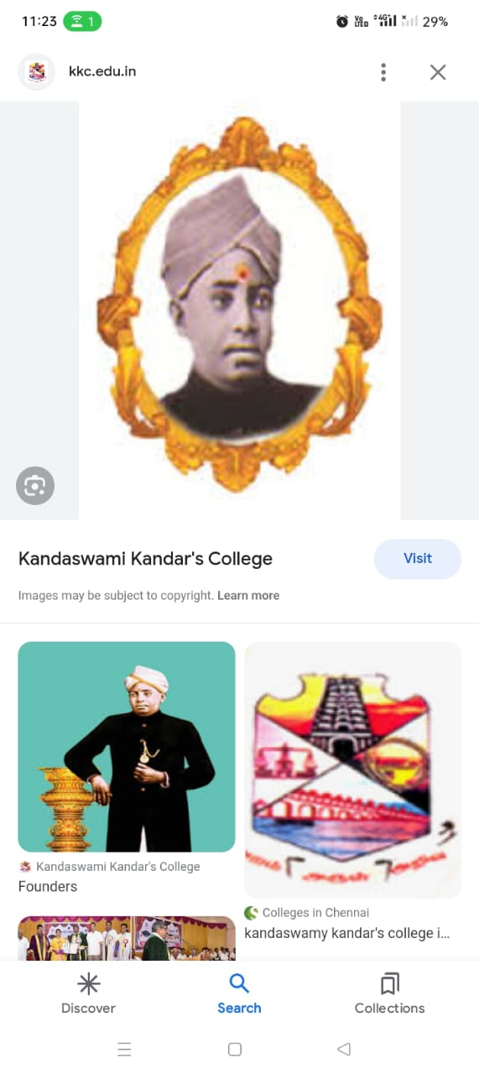 

**IREVOLUTION: A DATA-DRIVEN EXPLORATION**

**OF APPLE’S IPHONE IMPACT IN INDIA**

A PROJECT REPORT

SUBMITTED BY

**THESIKA. K**

**PREETHI. P**

**VAISHNAVI. G**

**VAISHNAVI. J**

**YALINI. R**

**BACHELOR OF SCIENCE**

**IN**

**MATHEMATICS**

**KANDASWAMI KANDAR’S COLLEGE, P. VELUR**

**(AFFILIATED TO PERIYAR UNIVERSITY SALEM)**

**PG & RESEARCH DEPARTMENT OF MATHEMATICS**

**OCTOBER - 2023**

**TABLE OF CONTENTS**

**1 INTRODUCTON**

1.1 Overview

A brief description about your project.

**1.2** Purpose

The use of this project. What can be achieved using this.

**2 PROBLEM DEFINITION & DESIGN THINKING**

2.1 Empathy Map

Paste the empathy map screenshot**.**

2.2 Ideation & Brainstorming Map

Paste the ideation & brainstorming map screenshot.

**3 RESULT**

Final findings (output) of the project along with screenshots.

**4 ADVANTAGES & DISADVANTAGES**

List of advantages and disadvantages of the proposed solution

**5 APPLICATIONS**

The areas where this solution can be applied.

**6** **CONCLUSION**

Conclusion summarizing the entire work and findings.

**7 FUTURE SCOPE**

Enhancements that can be made in the future.

**8 APPENDIX**

A. Source Code

Attach the code for the solution built.

**INTRODUCTION**

* 1. **PROJECT OVERVIEW**

The Apple iPhone is a revolutionary smartphone developed and manufactured by apple Inc. It was first introduced to the market on June 29, 2007, and has since influential consumer electronic devices worldwide.

The project aimed to create a device that combined multiple functionalities, such as a mobile phone, an internet communication device, and an iPod. The iPhone’s design and features were intended to offer a seamless user experience, intuitive interface, and superior performance.

**1.2 PURPOSE**

The purpose off the Apple iPhone is to provide users with a revolutionary smartphone that combines various functionalities, such as a mobile phone, an internet communication device, and an iPod.

The iPhone also prioritizes user privacy and security with features like Face ID and Touch ID. Additionally, it seamlessly integrates with other Apple devices and services, transfer files and communicate across multiple devices.

**PROBLEM DEFINITION & DESIGN THINKING**

**2.1 EMPATHY MAP**

An empathy map is a simple, easy-to-digest visual that captures knowledge about a user’s behaviours and attitudes. It is a useful tool to helps teams better understand their users.

Creating effective solution requires understanding the true problem and the person who is experiencing it. The exercise of creating the map helps participants consider things from the user’s perspective along with his or her goals and challenges.

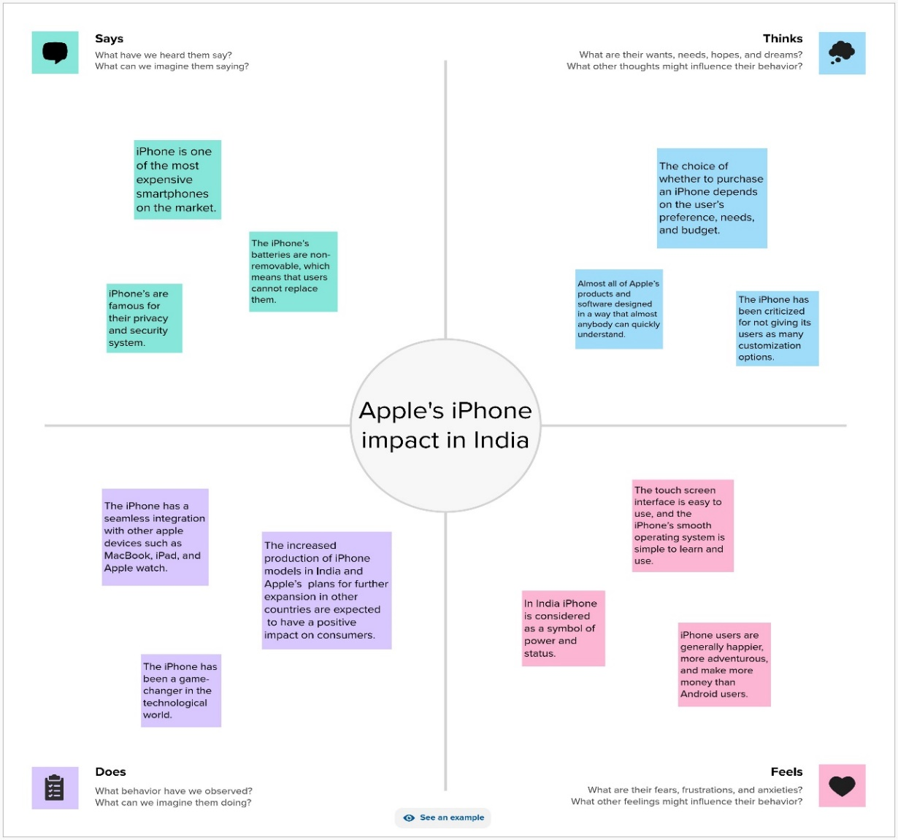

**2.2 IDEATION AND BRAINSTORMING**

Brainstorming provides a free and open environment that encourages everyone within a team to participate in the creative thinking process that leads to problem solving. Prioritizing volume over value, out-of-the-box ideas are welcome and built upon, and all participants are encouraged to collaborate, helping each other develop a rich amount of creative solutions.

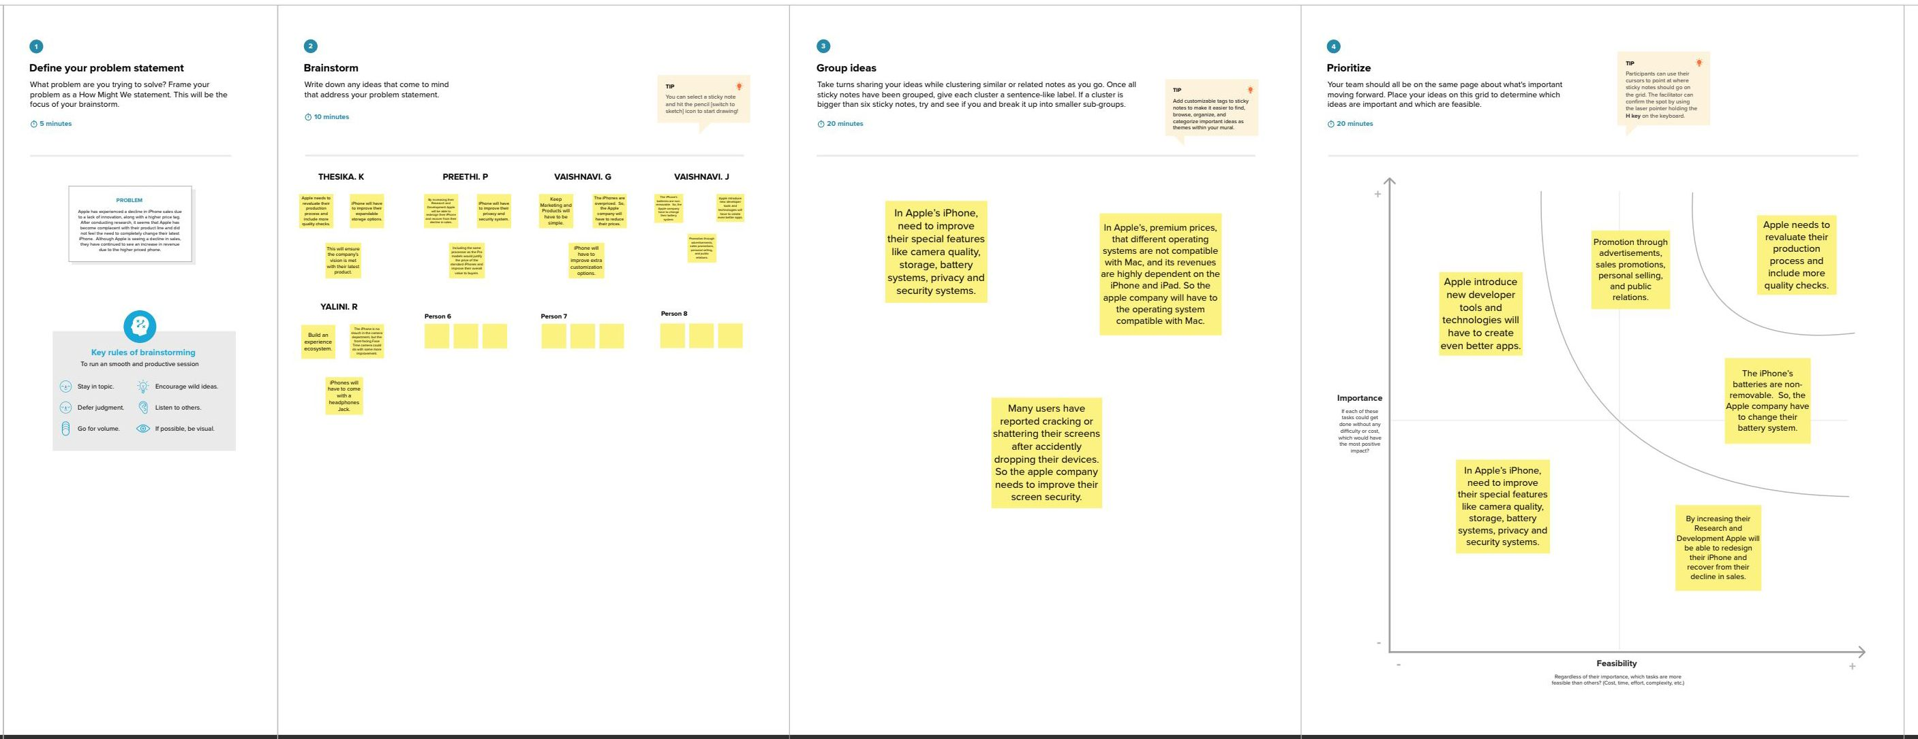

**RESULT**

OUTPUTS

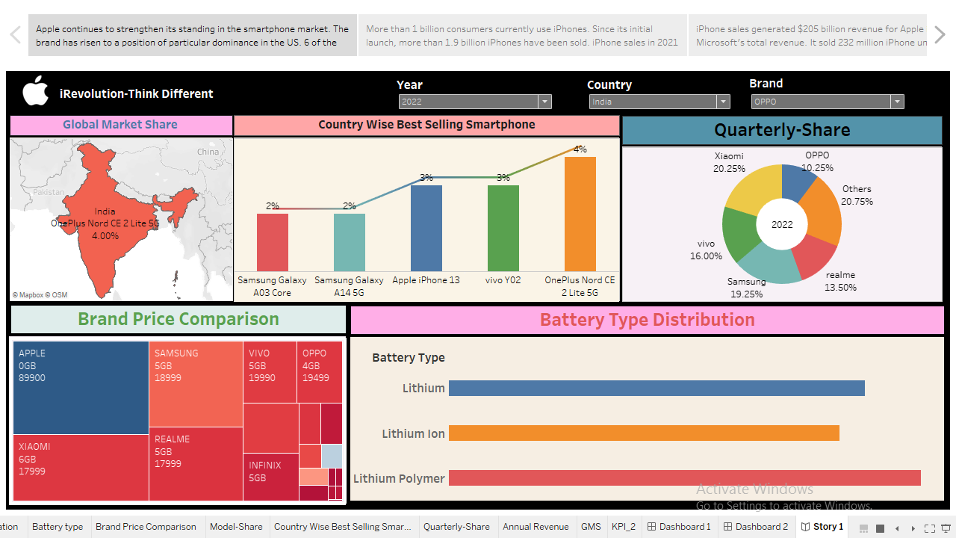

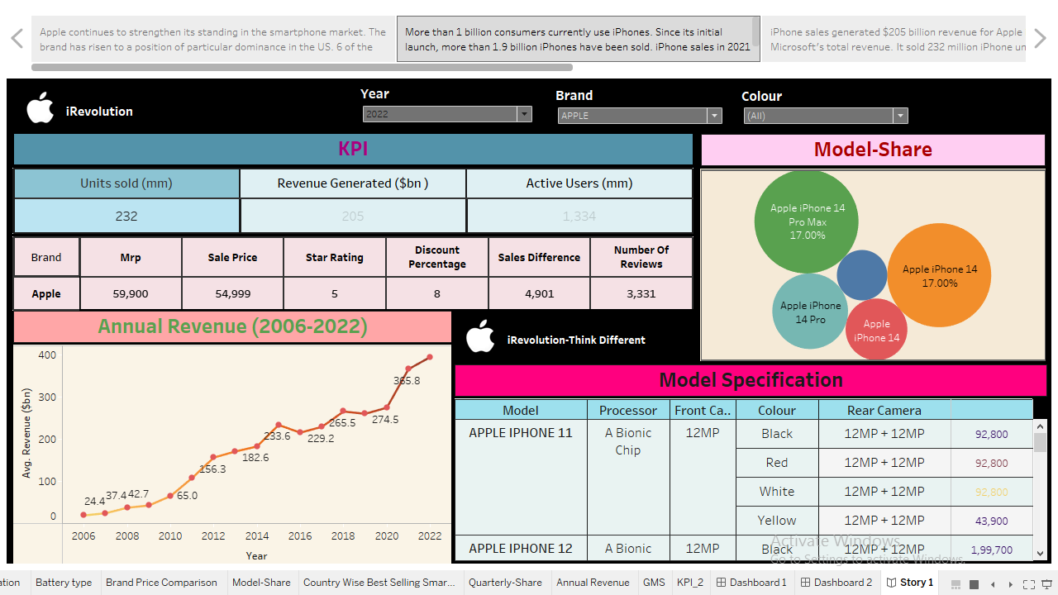

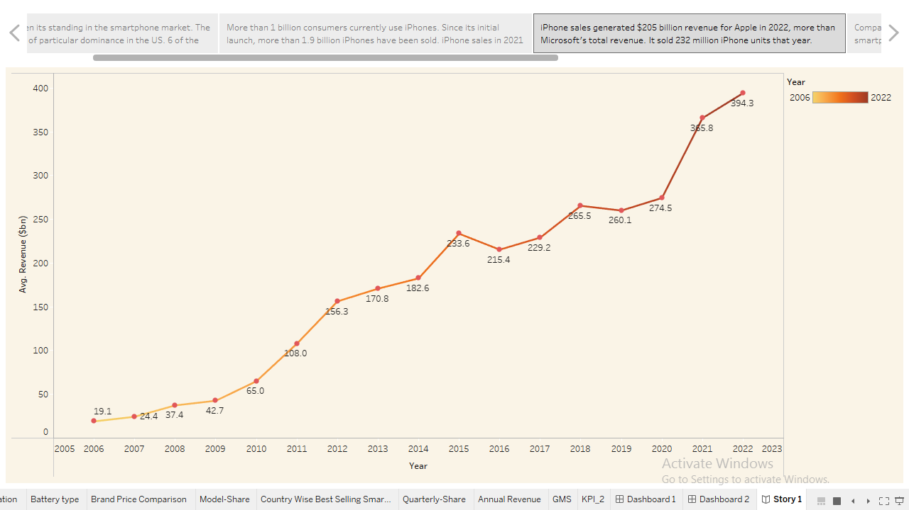

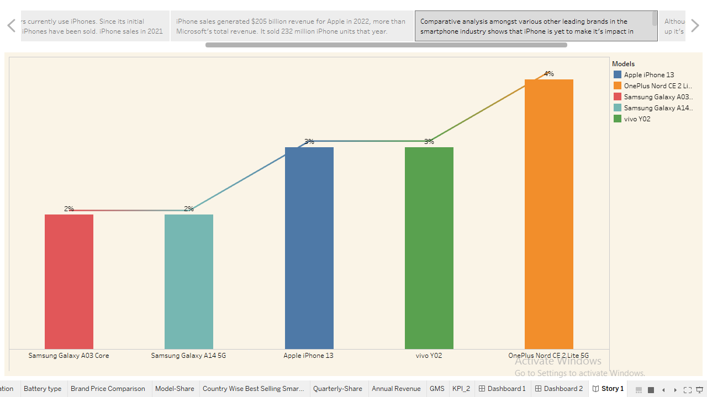

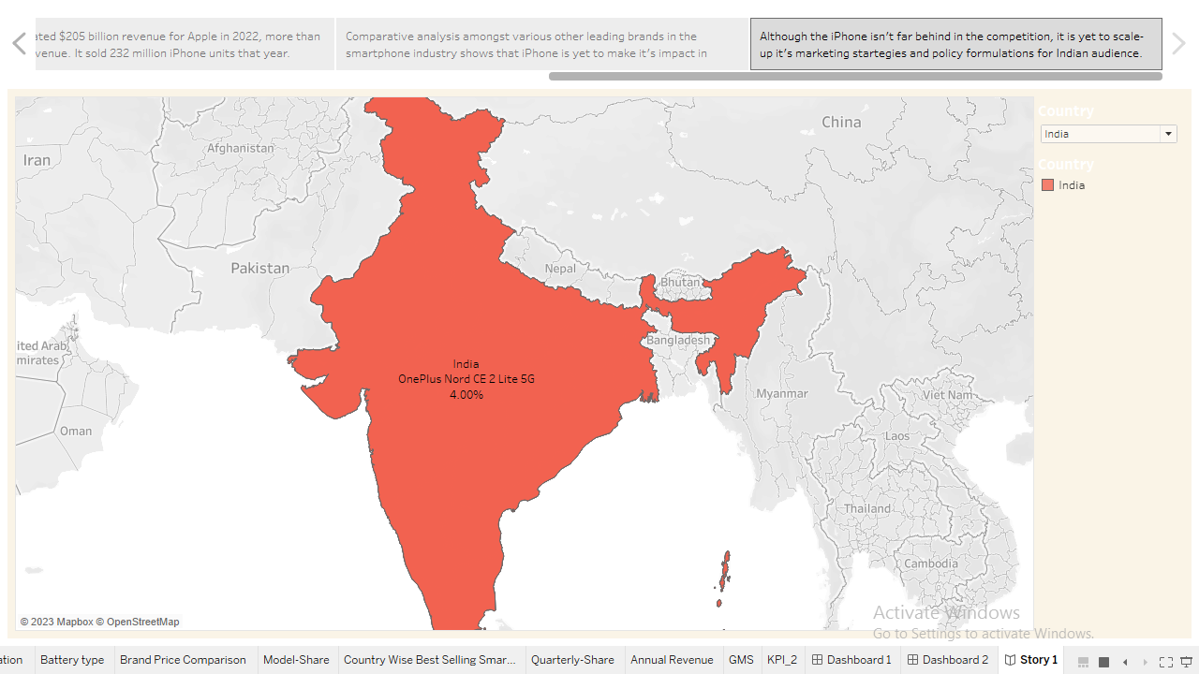

**ADVANTAGES AND DISADVANTAGES**

ADVANTAGES

1. Economic Impact
2. Digital Transformation
3. User Satisfaction
4. High Quality Display
5. Seamless Integration with Other Apple Devices
6. User-Friendly Interface

DISADVANTAGES

1. Non-Renewable Battery
2. Limited Customization
3. No Expandable Storage
4. Overpriced
5. iPhones Can Break Easily
6. Apple Ecosystem

**APPLICATIONS**

1. High price point
2. Limited range of models
3. Lack of customization options
4. Dependency on Apple’s ecosystem
5. Limited compatibility with non-Apple devices
6. Lack of expandable storage options

**CONCLUSION**

In this project, we conclude that, while Apple iPhones offer many attractive features and a sleek design, there are several drawbacks to consider. Limited compatibility with non-Apple devices can be a significant inconvenience for users who rely on cross-platform connectivity. The lack of expandable storage options may limit the amount of data that can be stored on the device**.**

**FUTURE SCOPE**

1**. Improved compatibility with non-Apple devices:** Apple could work on expanding compatibility with devices from other brands, allowing for seamless connectivity and data transfer between different platforms.

2. **Increased storage options**: Apple could introduce expandable storage options, such as microSD card slots, to allow users to store more data on their devices without relying solely on cloud storage.

3. **Enhanced durability**: Apple could focus on improving the durability of their iPhones, potentially through the use of stronger materials or reinforced designs, to reduce the risk of damage from accidental drops or impacts.

**APPENDIX**

1. SOURCE CODE

iRevolution:

A_data-driven_Exploration_Of_Apple’s_iPhone_Impact_In_India.pdf